|  |  |
| --- | --- |
| **Networking Infrastructure**  Diploma in CSF / IT  Apr 2022 Semester 3 | Week 5 |
| Session 1 |
| **Troubleshooting TCP/IP Networks** | |

**Objectives**

At the end of this lesson, students should be able to identify and use appropriate tools such as **ipconfig, ping, tracert, arp, netstat and nslookup** in troubleshooting a TCP/IP network.

**Activity 1: ipconfig**

1. Launch the Windows PowerShell on your computer. Type “ipconfig /all” at the command prompt. Cut the information for the Wireless LAN adapter and paste your screenshot in the box below.

|  |
| --- |
|  |

1. Are the IP addresses of the default gateway, DHCP server and DNS server the same? Explain the reason.

|  |
| --- |
| Yes. As the DHCP server is in the router, and the computer’s default gateway is obtained from the router. And because the router is responsible for using the DNS servers set up by the ISP, an the computer is connected directly to the router, hence the DNS server IP will be the same as the router’s. |

**Activity 2: ping**

1. Try to “ping” your default gateway and paste your screenshot in the box below. Discover the various options for ping using “ping /?”.

|  |
| --- |
|  |

1. Ping your default gateway (x.x.x.x) with the following options:
2. Ping x.x.x.x –t

Observe and explain, what is the function of “-t” in this command.

|  |
| --- |
| The default gateway is pinged continuously until manually stopped. The function of “-t” in this command will ping the specified host until stopped. |

1. Ping x.x.x.x –l

Figure out yourself the command to ping your default gateway with 20 bytes of data (default is 32 bytes). Paste your screenshot in the box below.

|  |
| --- |
| It changes the size of bytes sent to a specified size |

1. Figure out yourself the command to ping your default gateway with 20000 bytes of data. Paste your screenshot in the box below.

What are your observations when comparing the Average round trip time with the value in part (ii)?

|  |
| --- |
| The average round trip time when pinging 20000 bytes of data is 2ms longer than the average round trip time when pinging 20 bytes of data. |

1. What is the default TTL for Ping and what does it specify? What option would you use to specify a different TTL value?

|  |
| --- |
| Default TTL = 64. It specifies the value for the period of time that a packet should exist on a computer or network before being discarded. “-i TTL” can be used to specific a different TTL value. |

**Activity 3: Tracert**

1. There are many online tools to perform ping, tracert, etc. Visit the following web site <https://centralops.net/co/> to test the “tracert” command.
2. From the PowerShell in your laptop, “tracert” to [www.google.com](http://www.google.com) and paste your screenshot below. How many hops to reach the Google Web Server?

|  |
| --- |
| 22 Hops |

**Activity 4: nslookup**

1. Type “nslookup facebook.com in your command prompt and paste your screenshot below.

|  |
| --- |
|  |

1. Do a simple research and find out the meaning of “Non-authoritative answer”.

|  |
| --- |
| A “non-authoritative answer” is an answer that is not fetched from the authoritative DNS server for the queried domain name. |

**Activity 5: netstat**

1. Do a search and find out the purpose of “netstat”.

|  |
| --- |
| To print network connections, routing tables, interface statistics, masquerade connections, and multicast memberships |

1. Try to type netstat from your command prompt and paste your screenshot below. (If there is no active TCP/IP connections, use the Internet Explorer to access a website. Run netstat again and record your results).

|  |
| --- |
|  |

1. Note that netstat is useful to troubleshoot TCP connections and can be used to check for unauthorized TCP connections.
2. To see the various options available, key in “netstat /?”
3. Key in the command netstat –s and observe the statistics display for the protocol.
4. Try other options such as netstat –r and note the result.

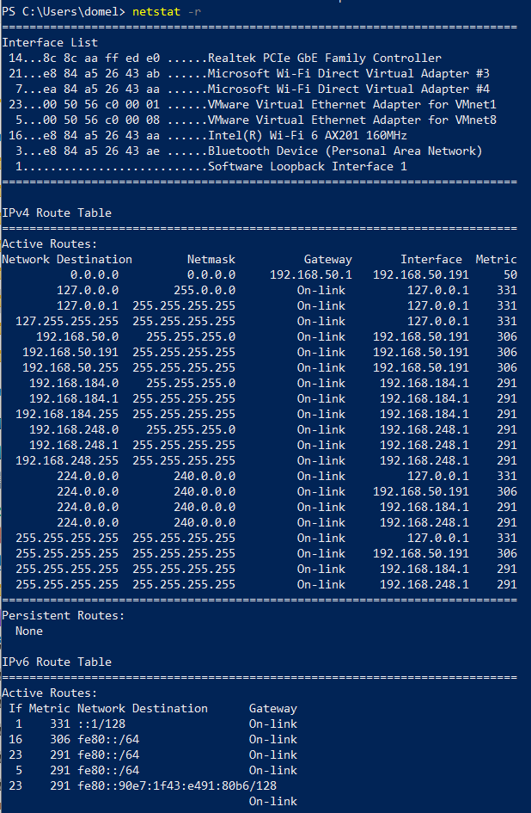

**Activity 6: arp**

This is used to view the ARP cache on the local computer. You can do a simple research to understand more on it. You may also use ARP to return the NIC address of a known IP address.

1. Type arp –a in your machine. What information is displayed when you key in this command? Paste your screenshot in the box below.

|  |
| --- |
|  |

**(Optional)**

**Activity 7: SSH**

**You must know the address of the remote host computer before you can initiate a session with SSH.**

SSH lets you sit at one computer and log on to a remote computer across the network. The connection can be to a machine in the same room, on the same campus, or a computer on the World Wide Web somewhere else in the world.

You can invoke the SSH from PuTTY program on your own computer.

**Activity 8: nslookup**

You can try the below nslookup command when you are in campus.

1. Type nslookup in the command prompt. Write down the result.
2. Continue to type set q=all
3. Continue to type facebook.com
4. Write down the result and your observation.
5. Type set q=mx
6. Type facebook.com and write down the result. Write down your observation.